RC: RNN + CNN1D

CP: CNN1D + parallel structure

CR: CNN1D + residual block

X: XGBoost

S: SVM

A: ANN

Tr: Training set

V: Validation set

T: Test set

Files[5]: G07_Freezing_Trial1_trial_1_emg.csv

Files[6]: G08_FoG_1_trial_1_emg.csv

Files[7]: G08_FoG_2_trial_1_emg.csv

Files[30]: G09_Walking_trial_2_emg.csv

Files[31]: G09_Walking_trial_4_emg.csv

Files[32]: G09_Walking_trial_6_emg.csv

Files[33]: G11_Walking_trial_2_emg.csv

Files[34]: G11_Walking_trial_4_emg.csv

Files[35]: P231_M050_A_Walking_trial_2_emg.csv

## Drop Files[6,30,31,32,33,34,35]:

**0 : others**

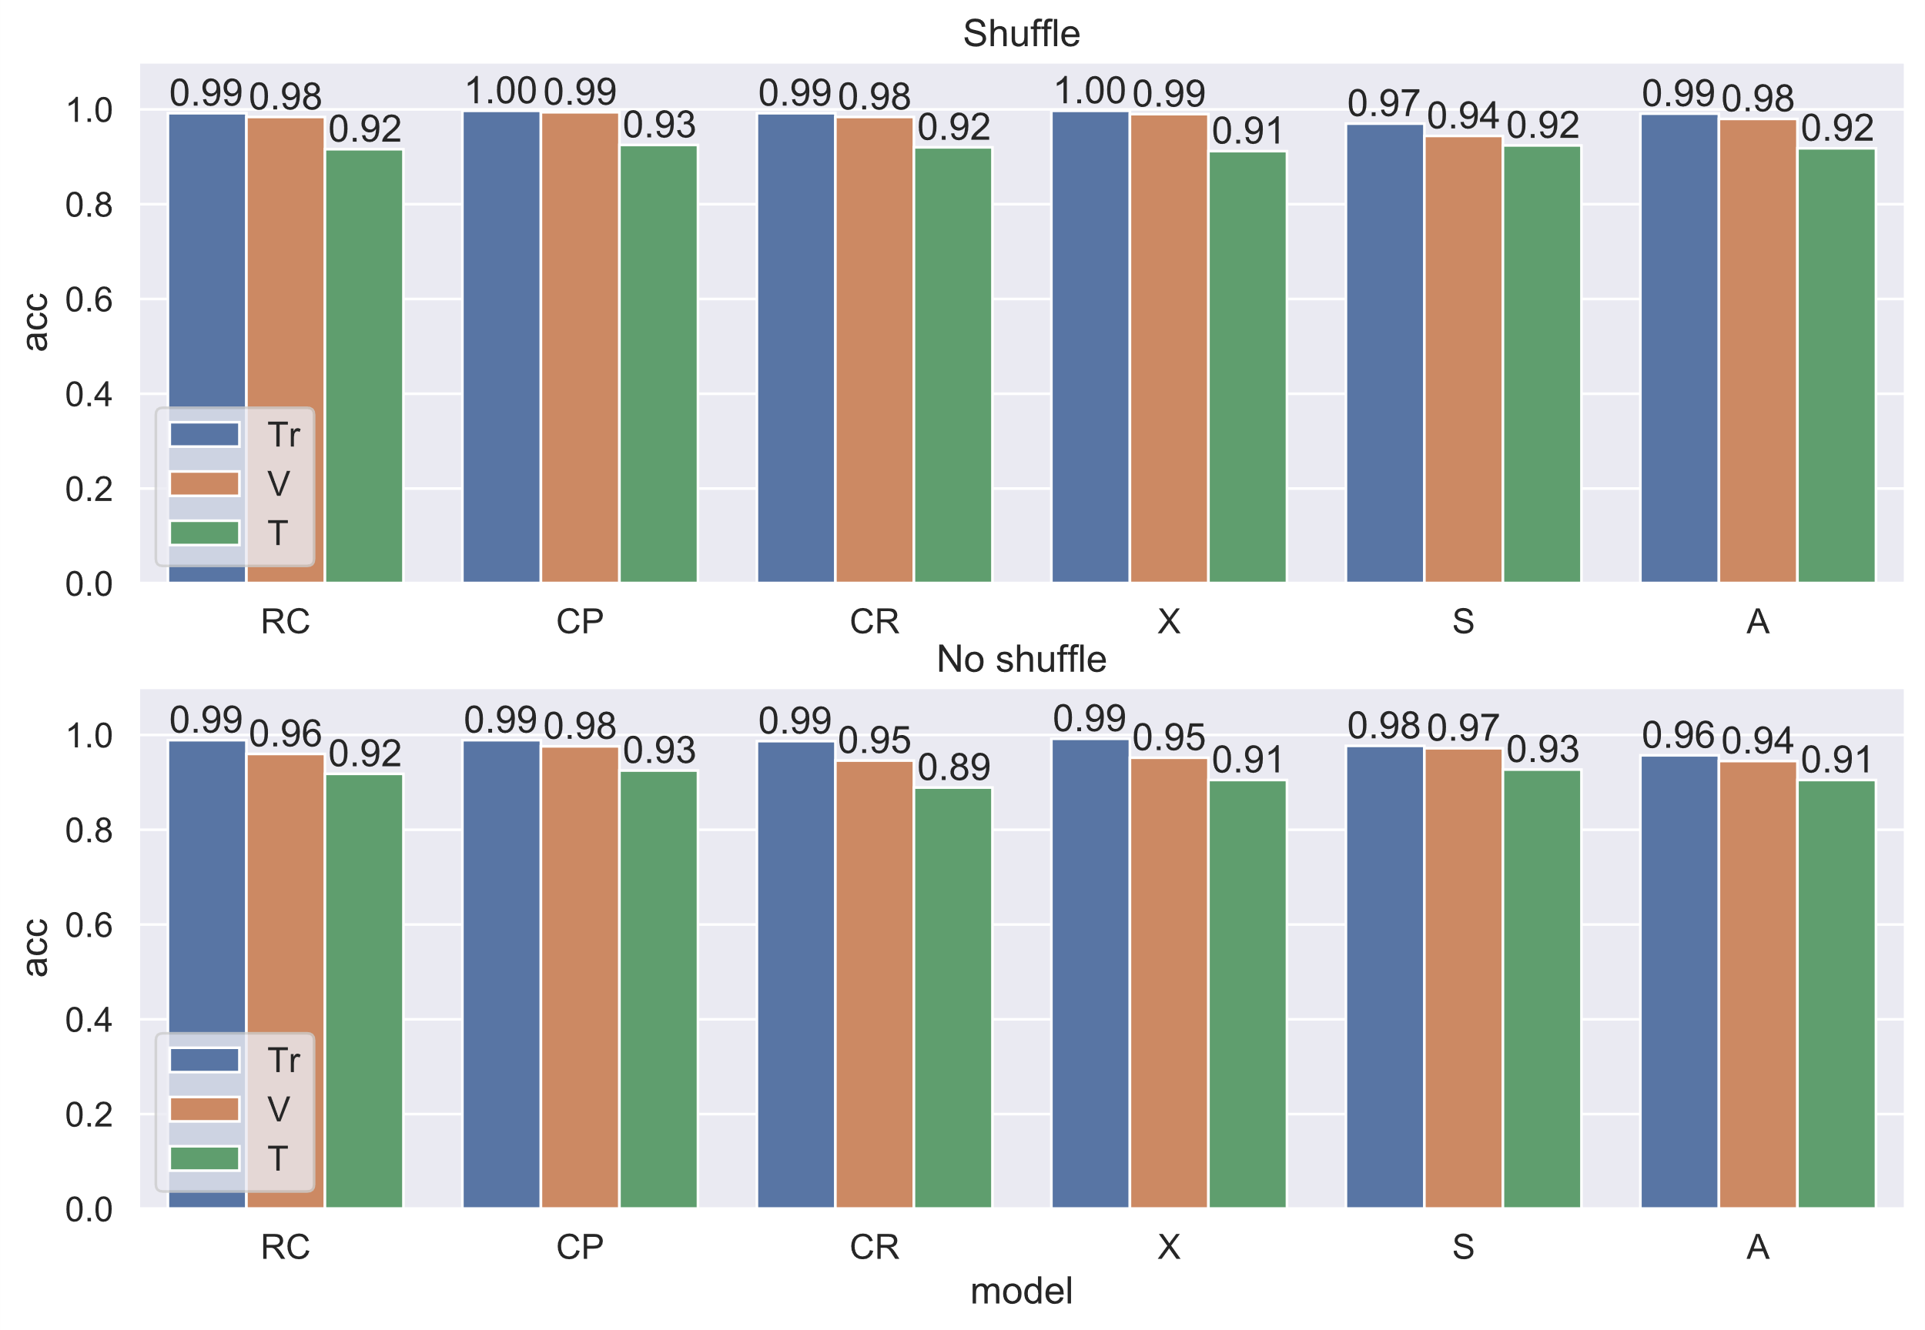

**1 : 2 : 6**

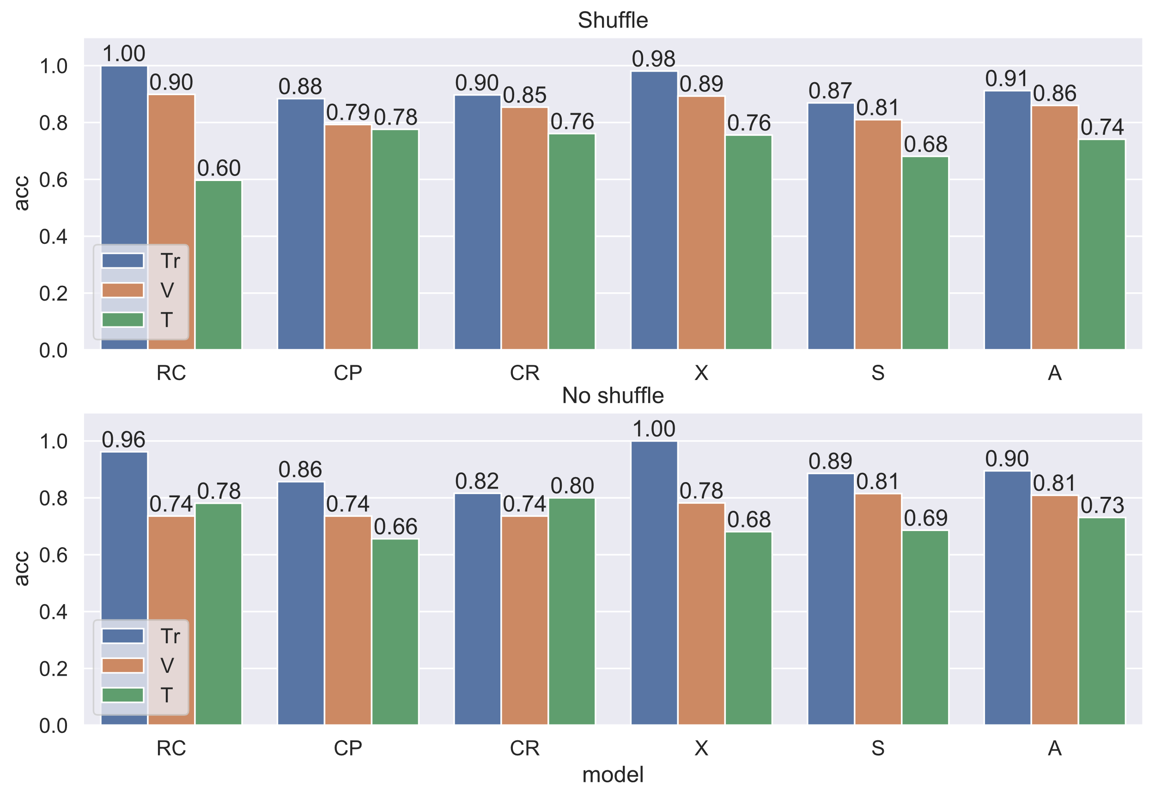

**2 : 6**

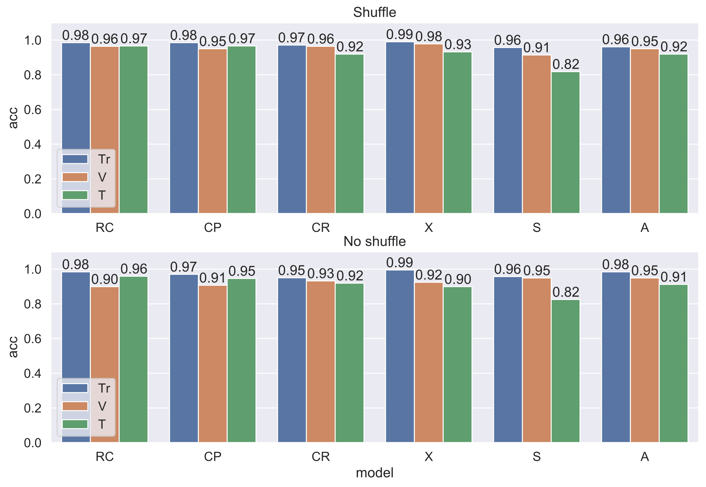

**1 : 6**

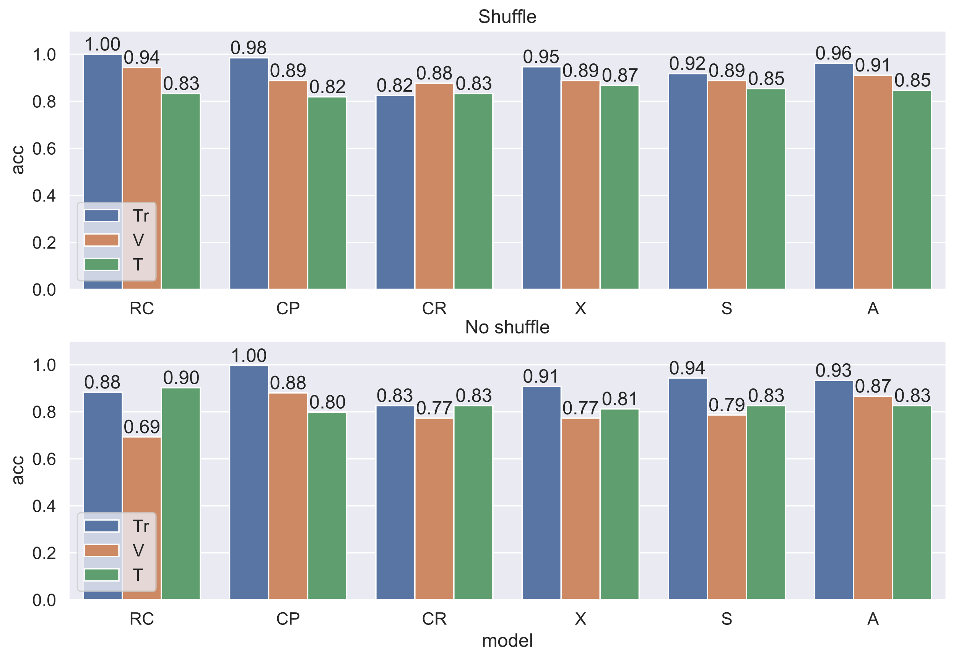

**1 : 2**

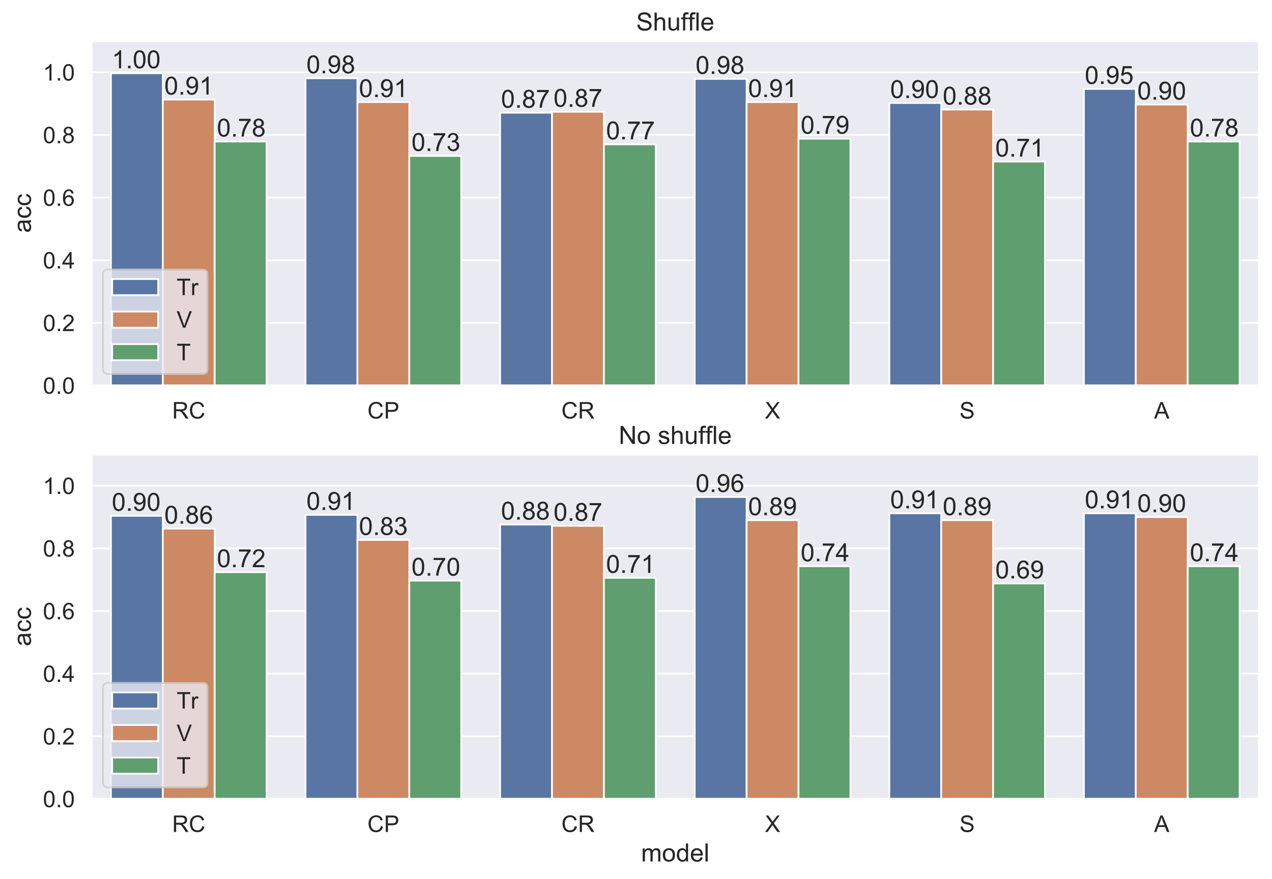

## Drop Files[7,30,31,32,33,34,35]

**0 : others**

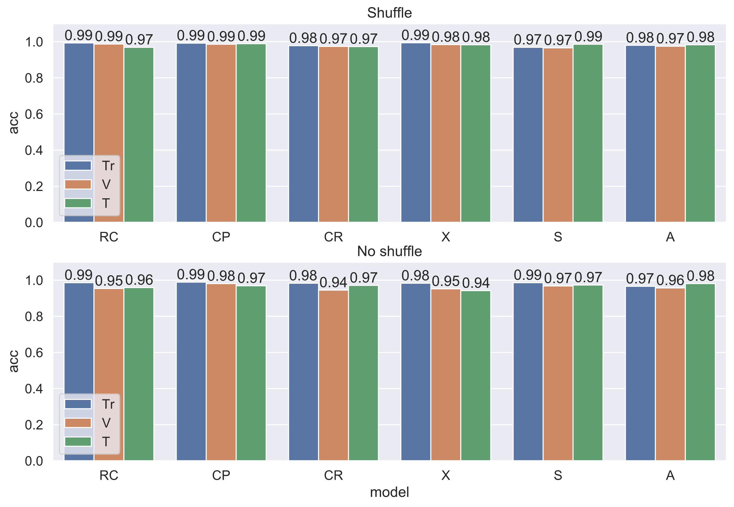

**1 : 2 : 6**

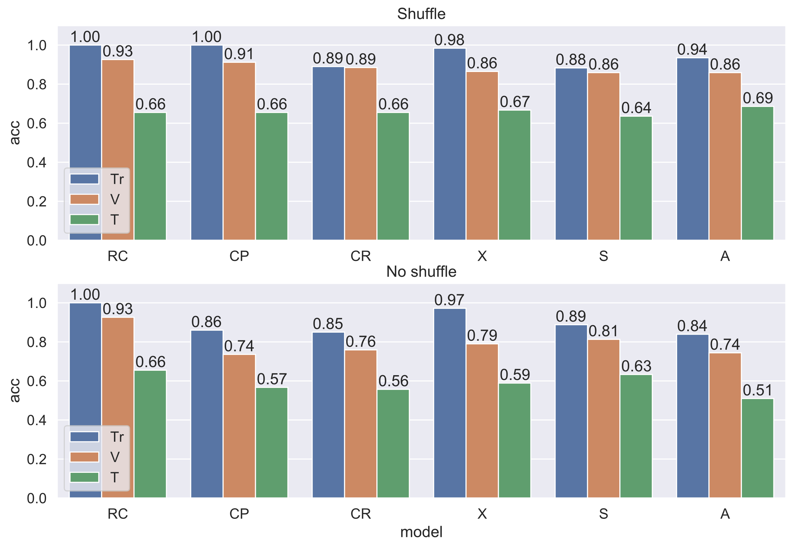

**2 : 6**

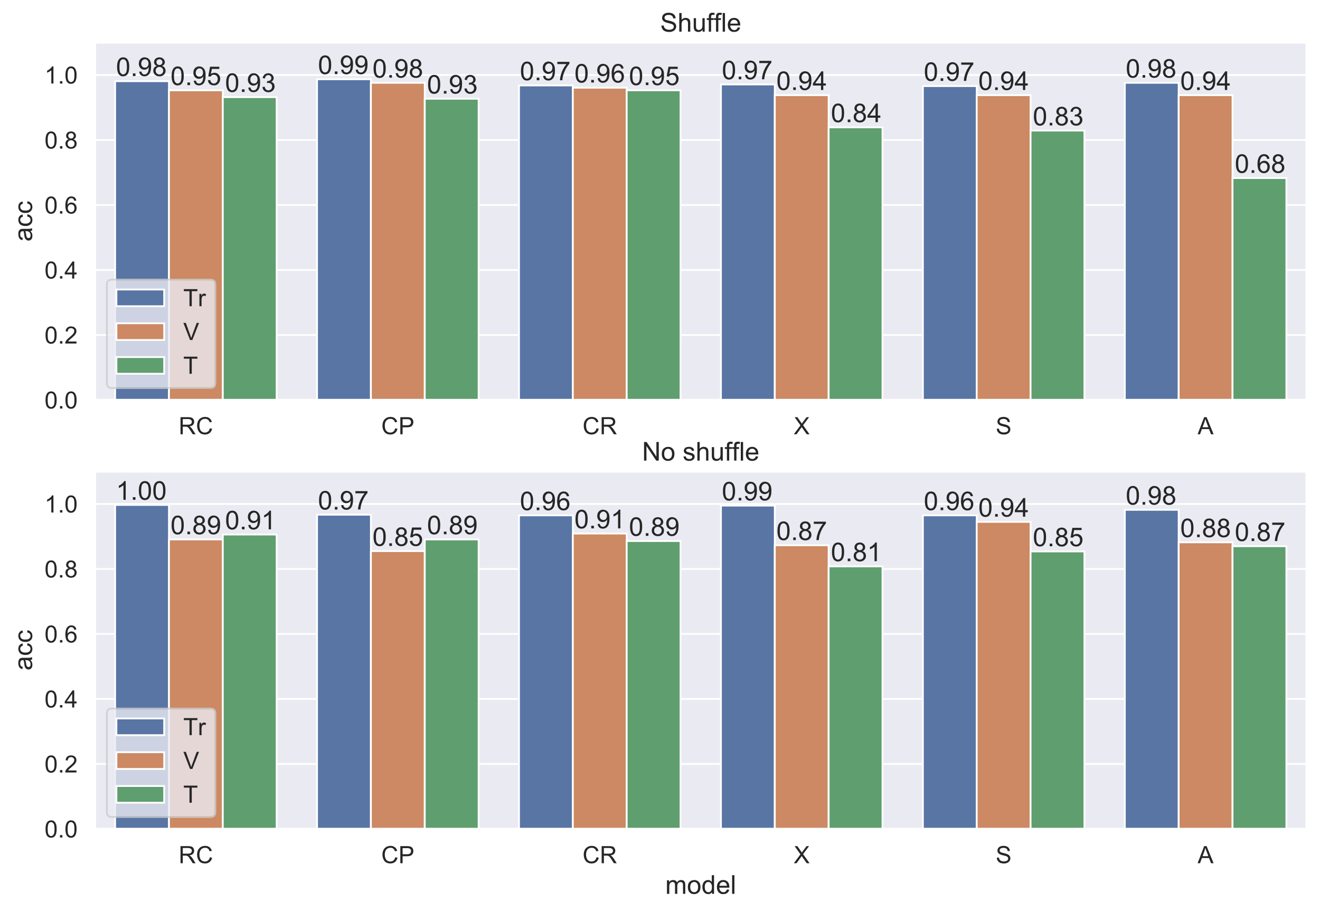

**1 : 6**

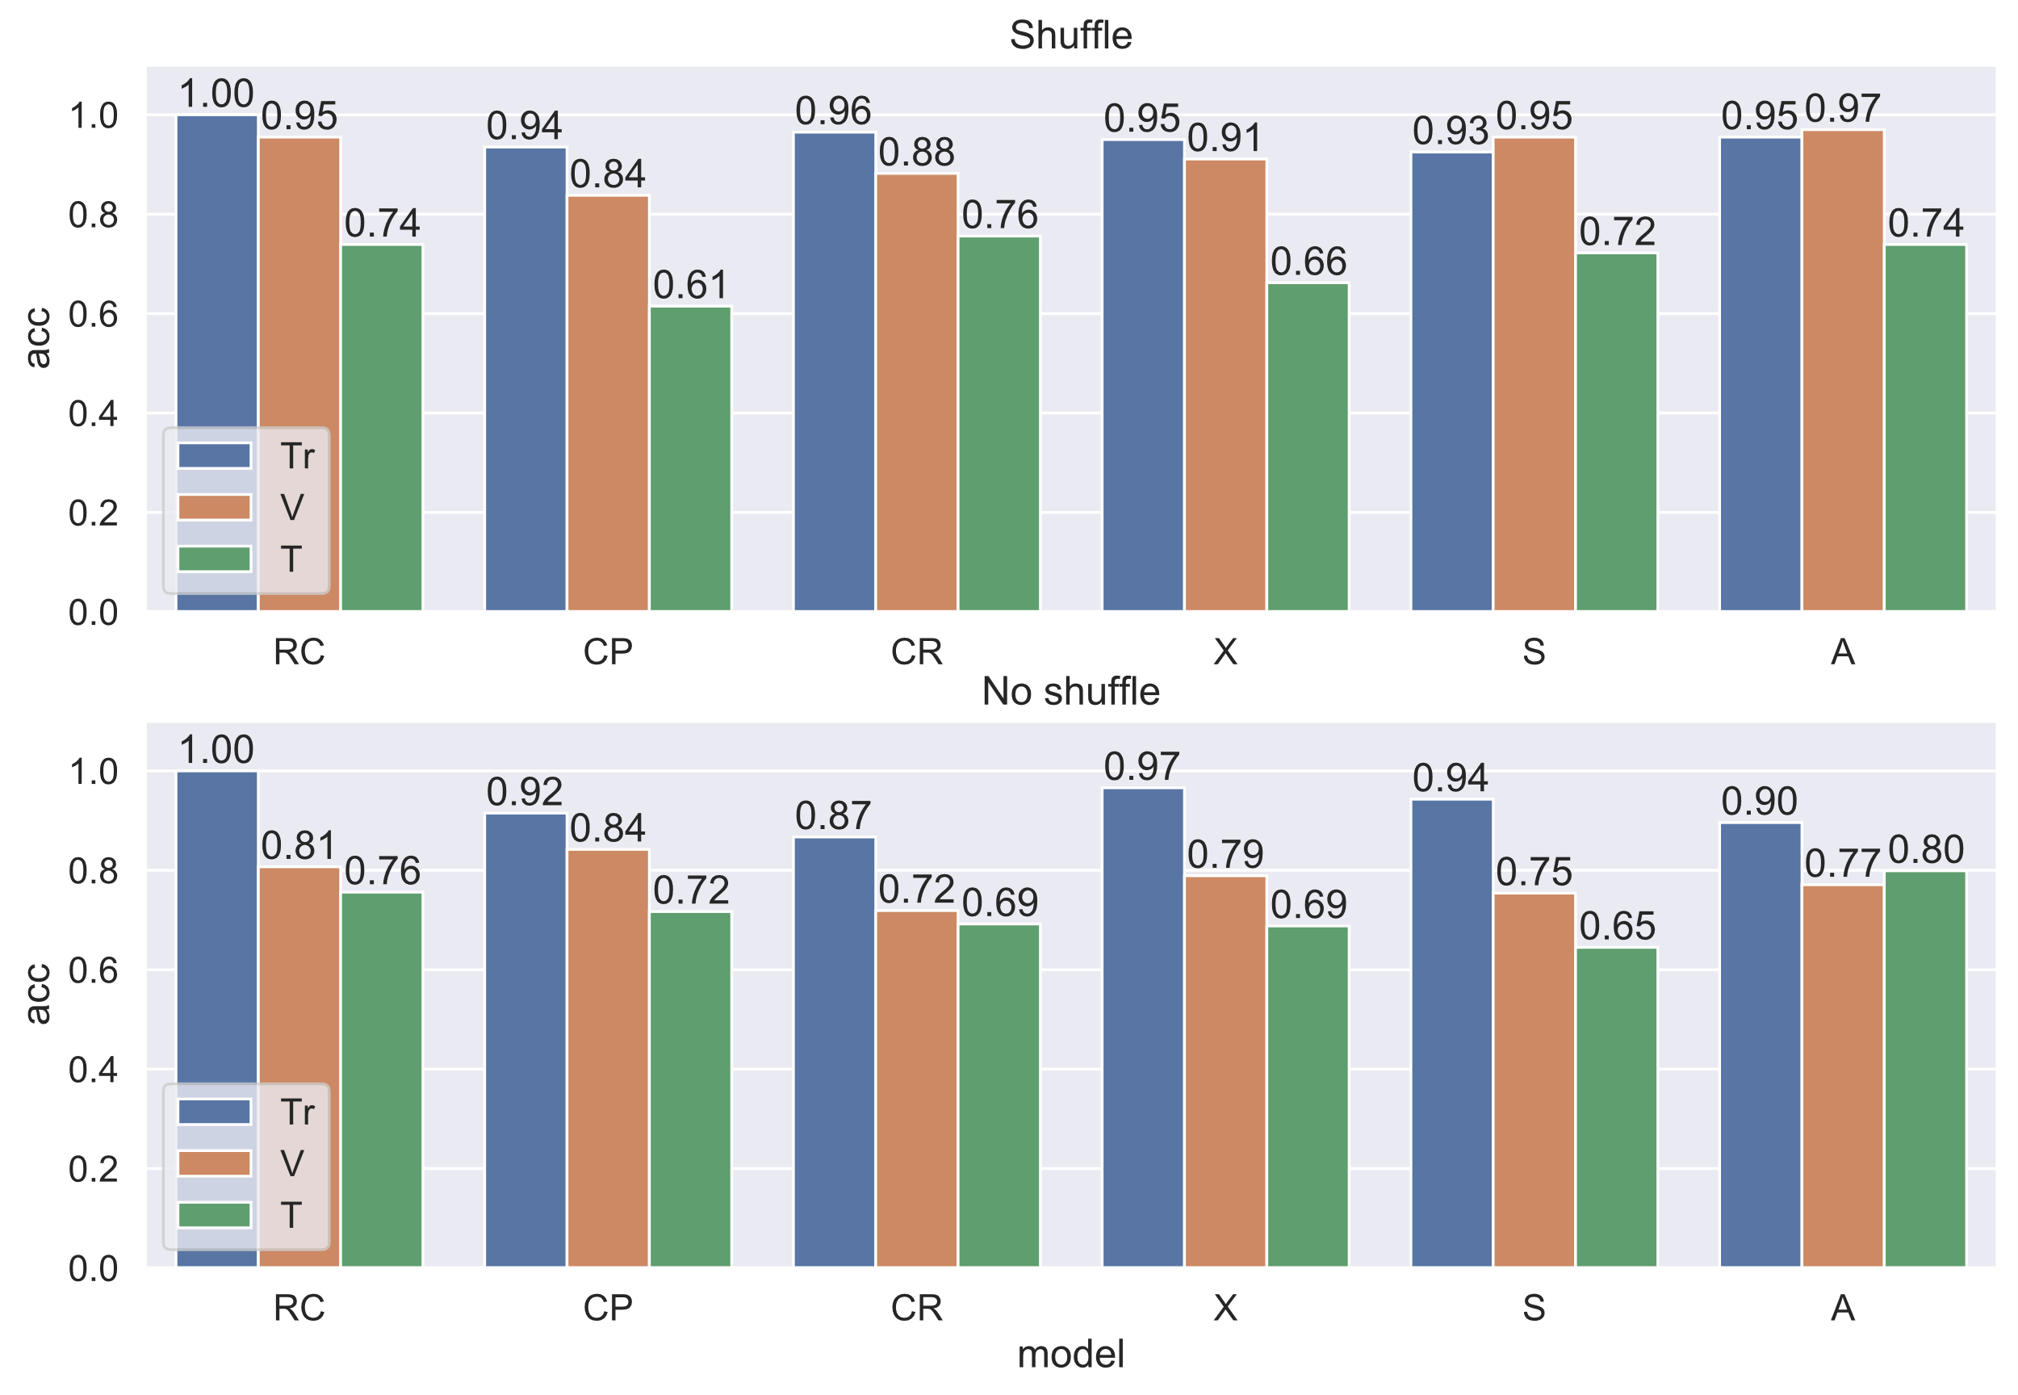

**1 : 2**

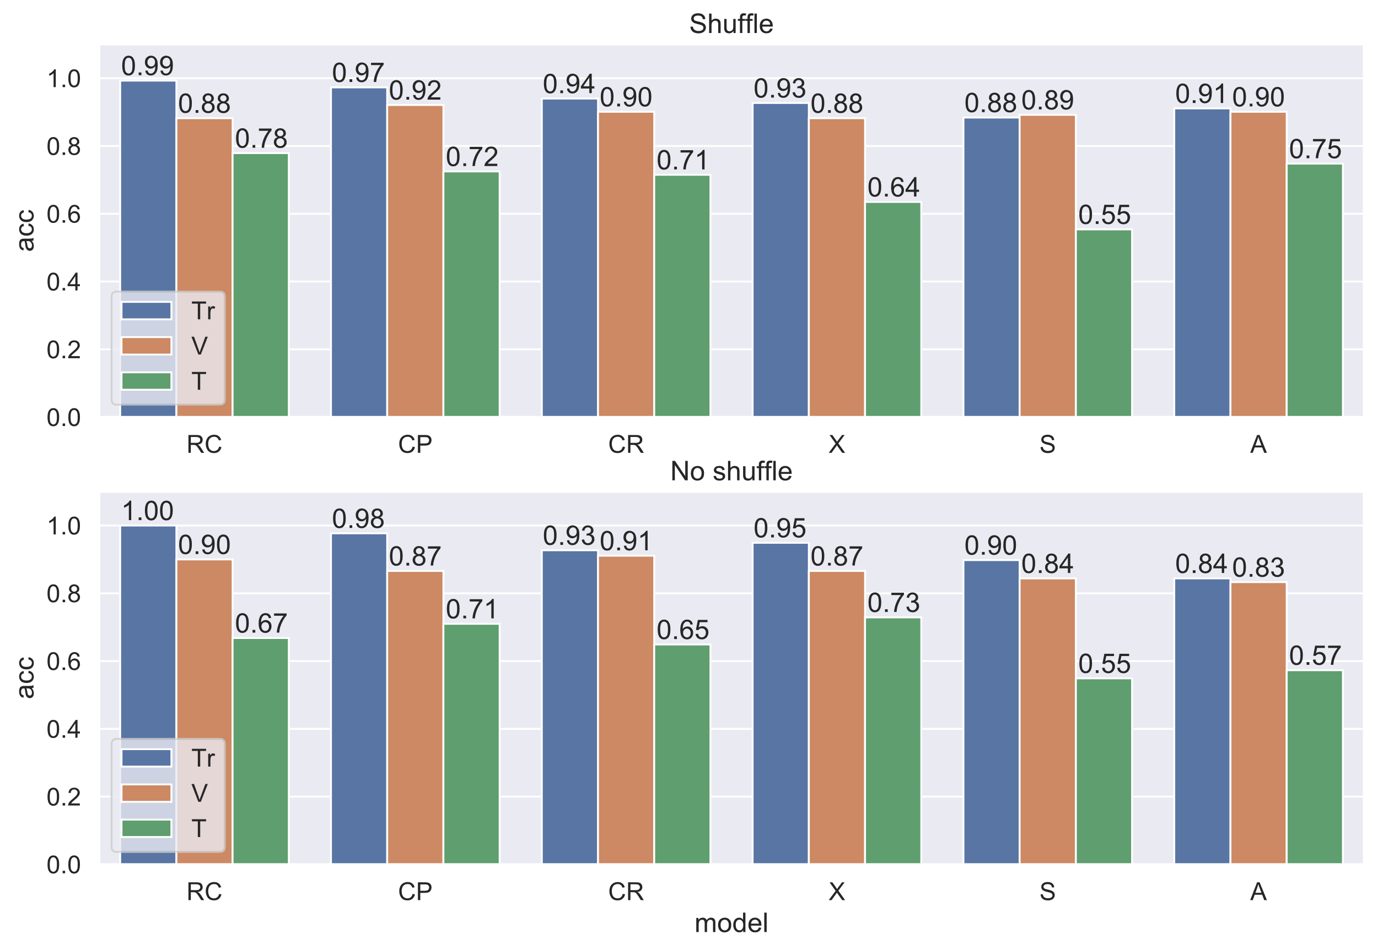

## **Drop** Files[5,30,31,32,33,34,35]

**0 : others**

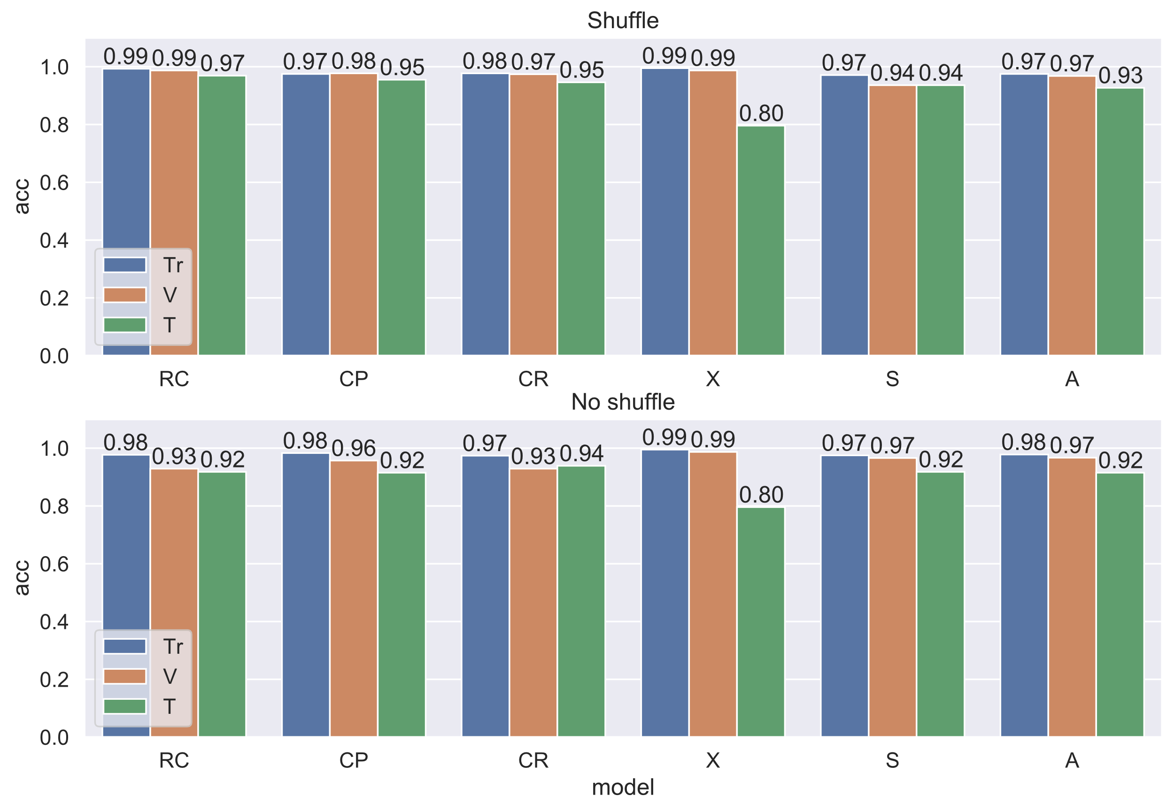

**1 : 2 : 6**

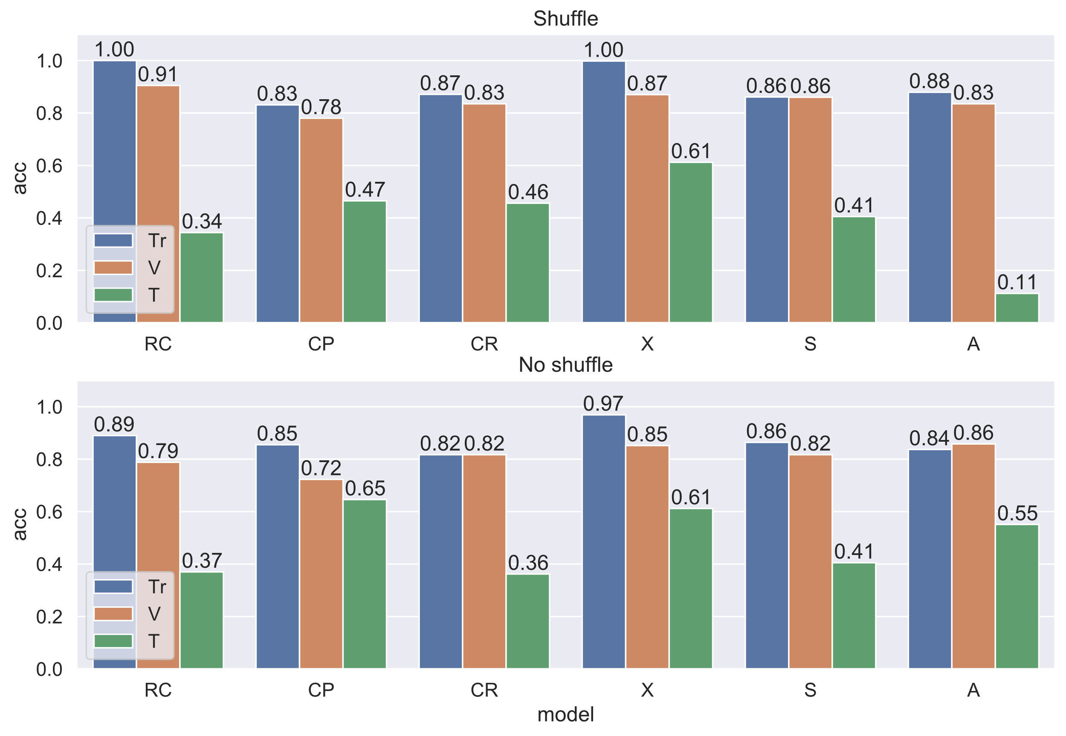

**2 : 6**

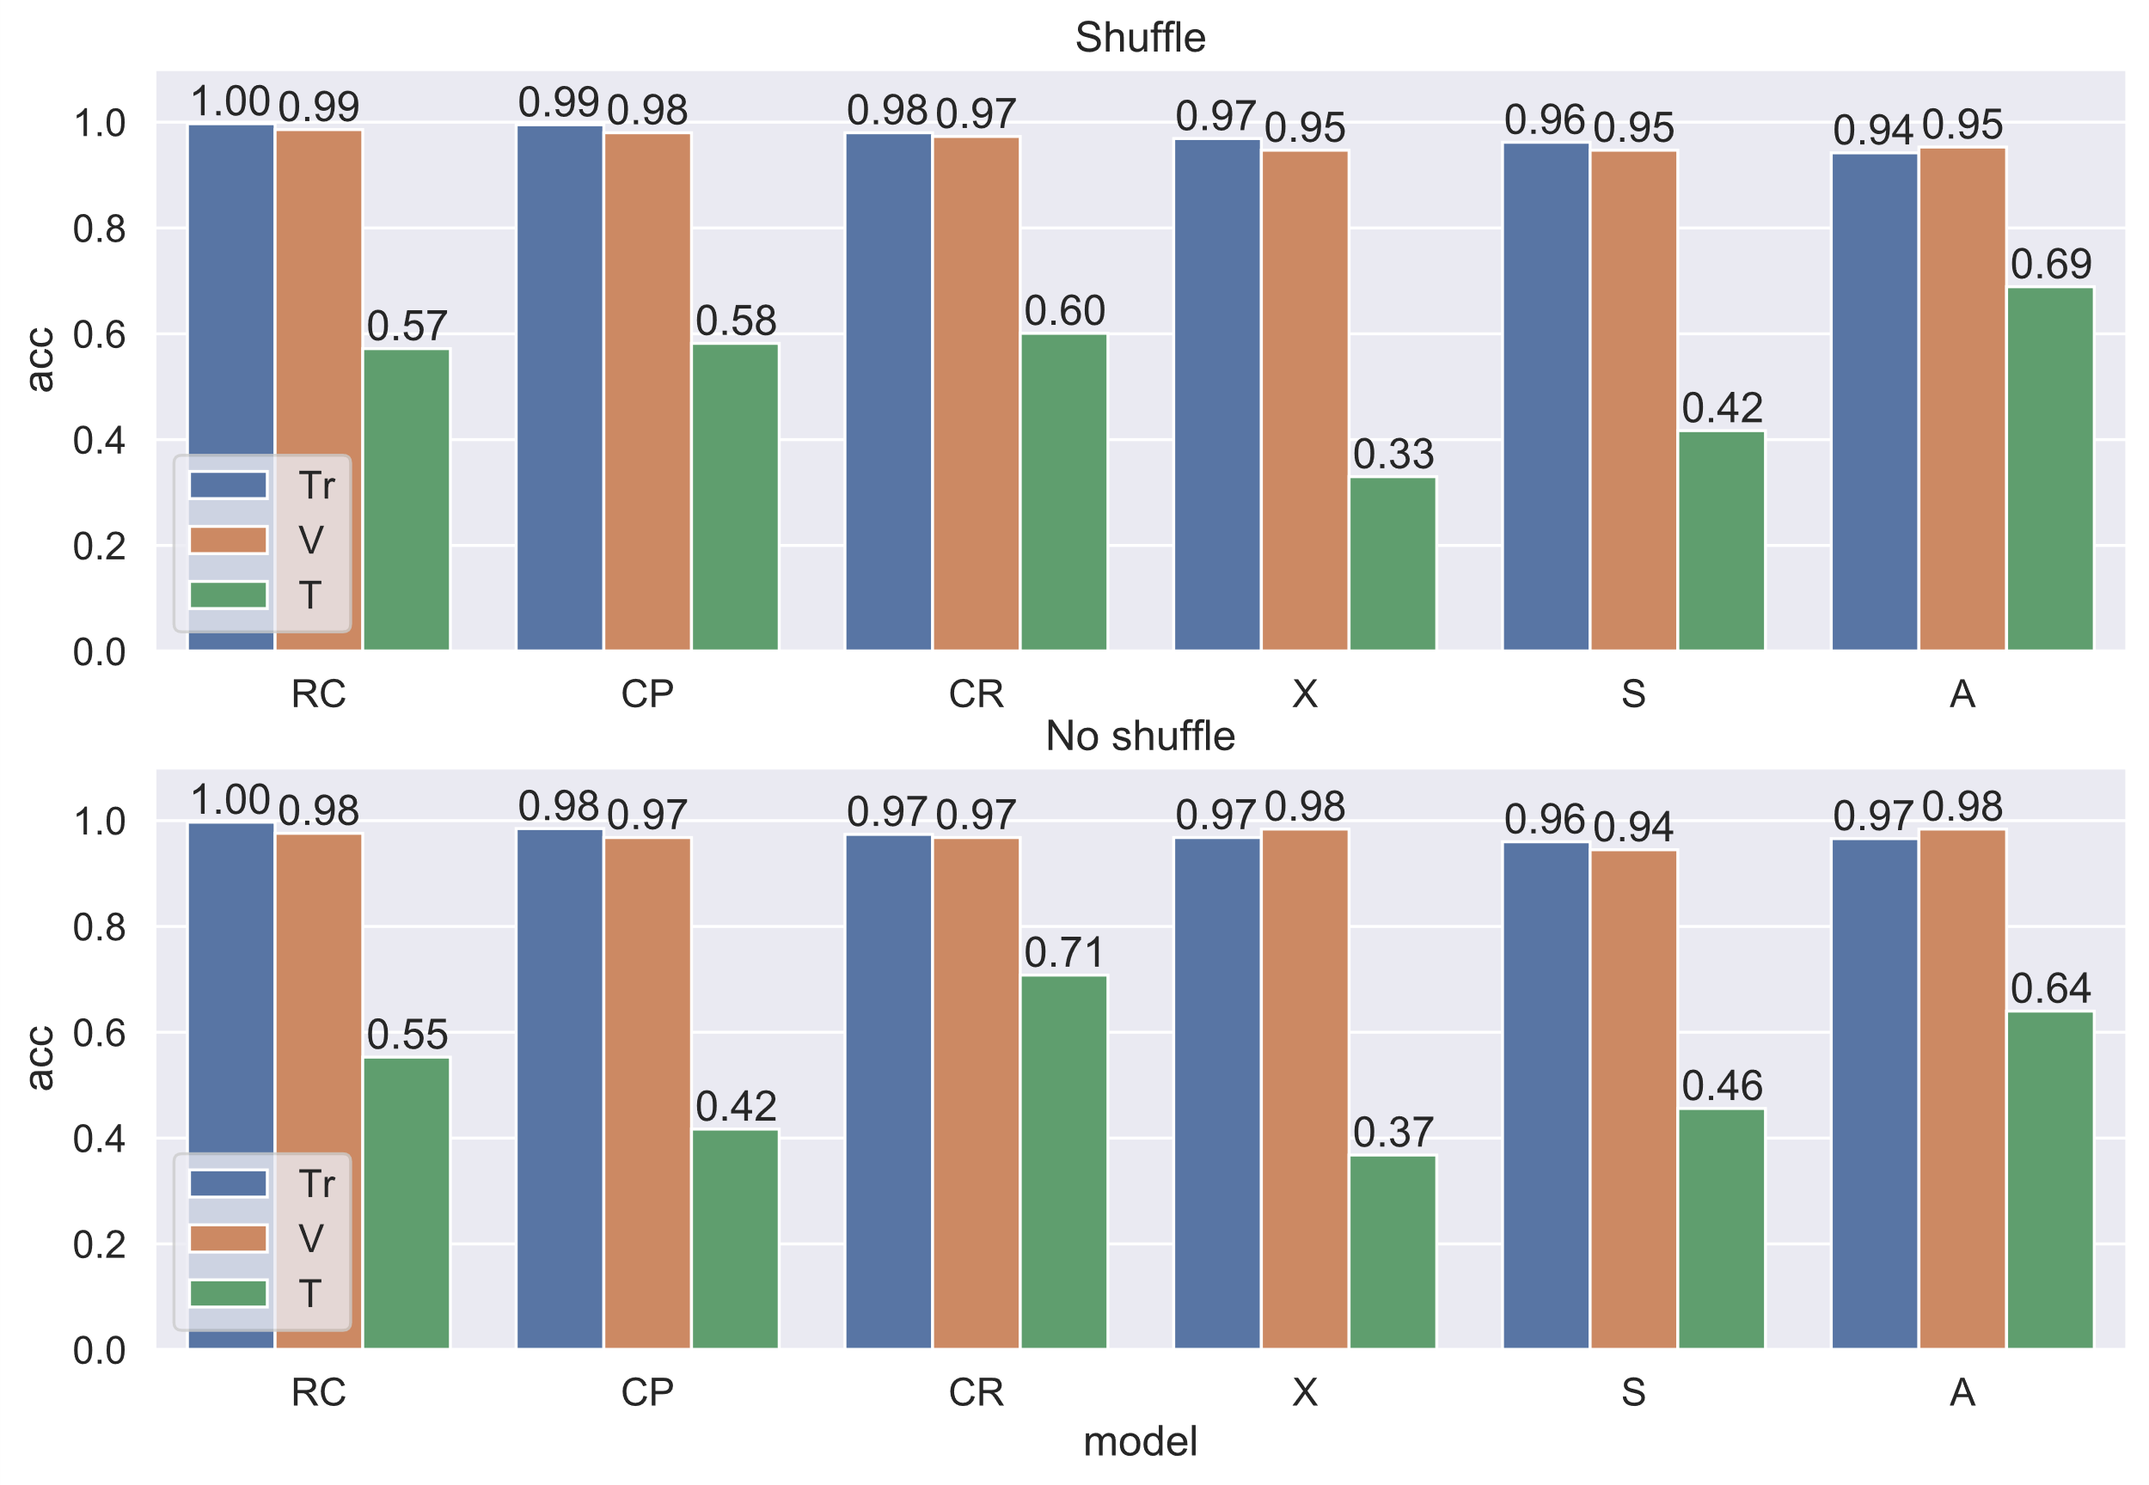

**1 : 6**

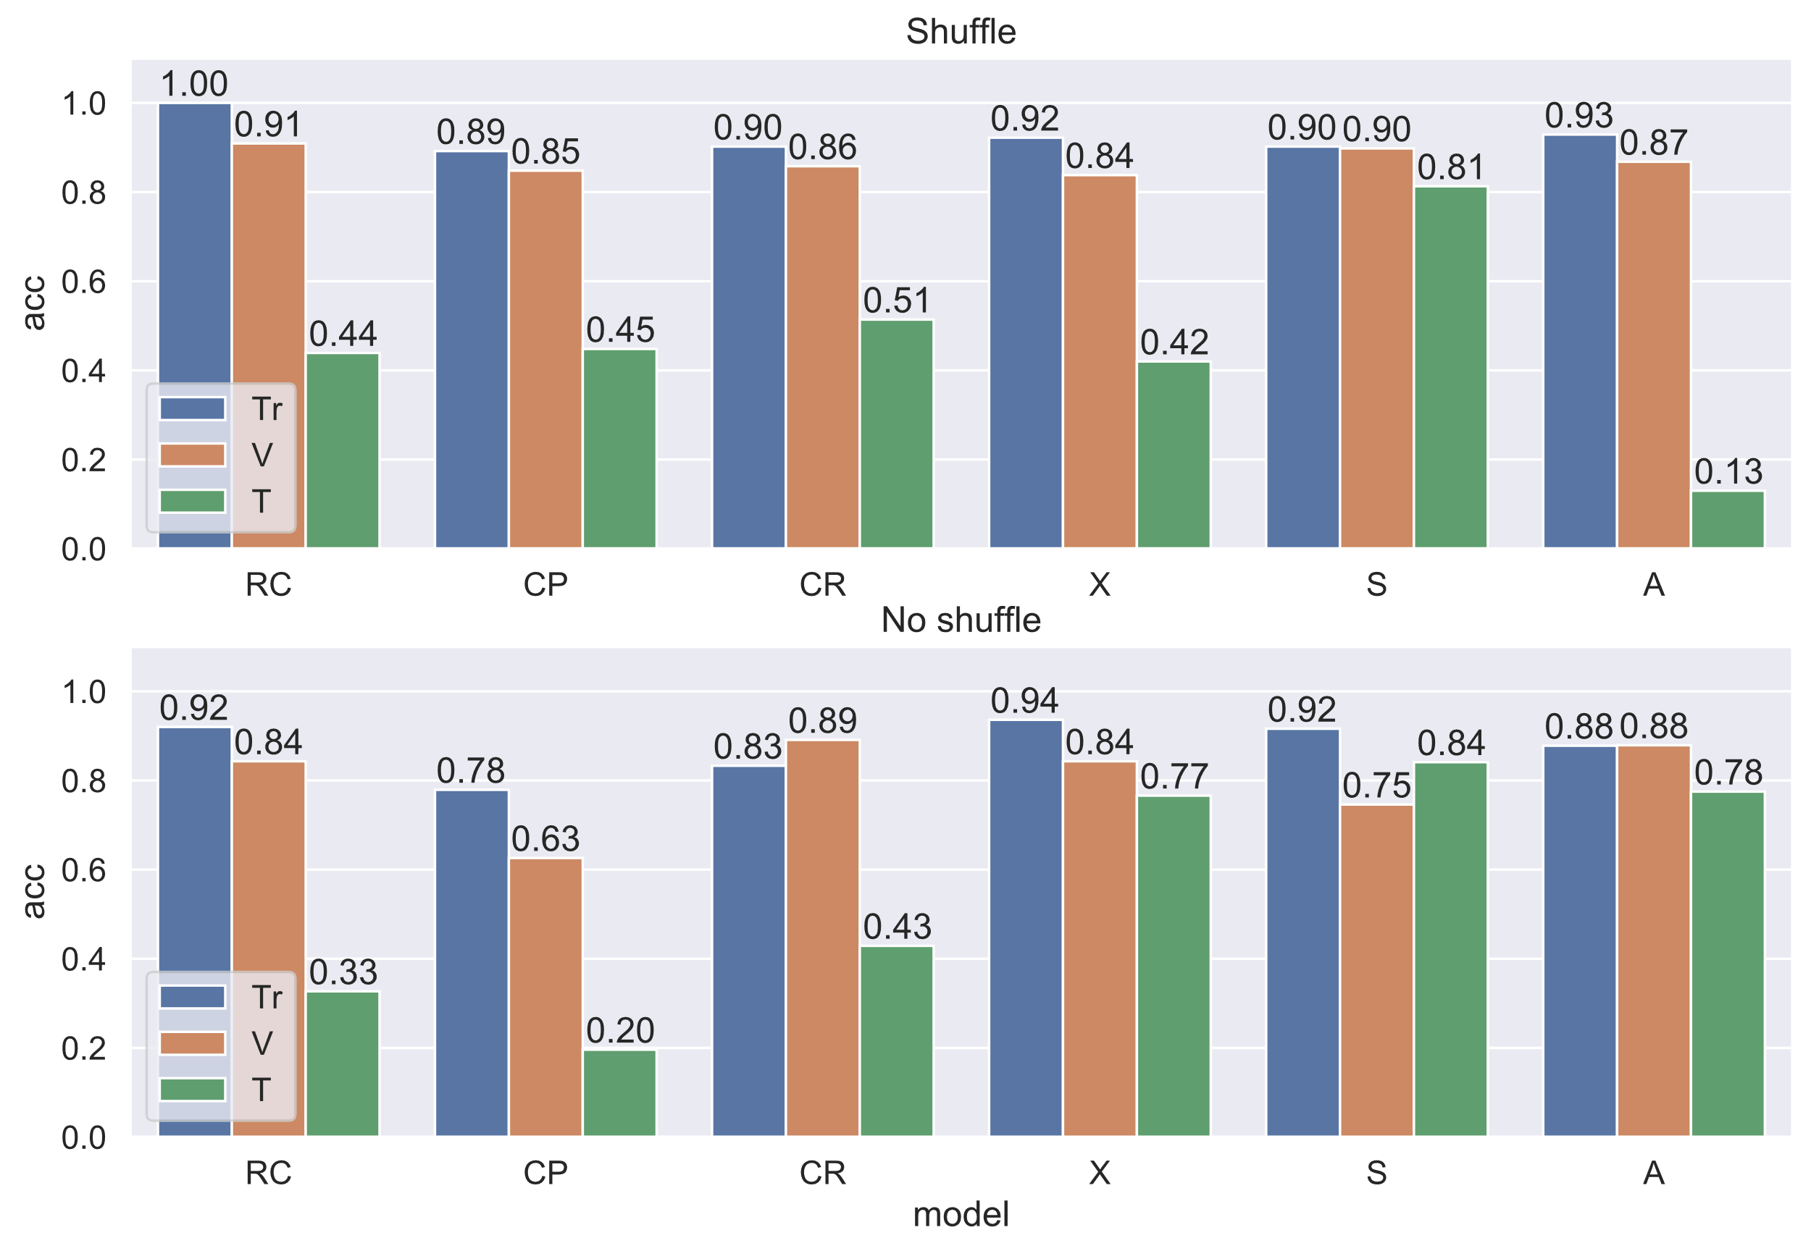

**1 : 2**

